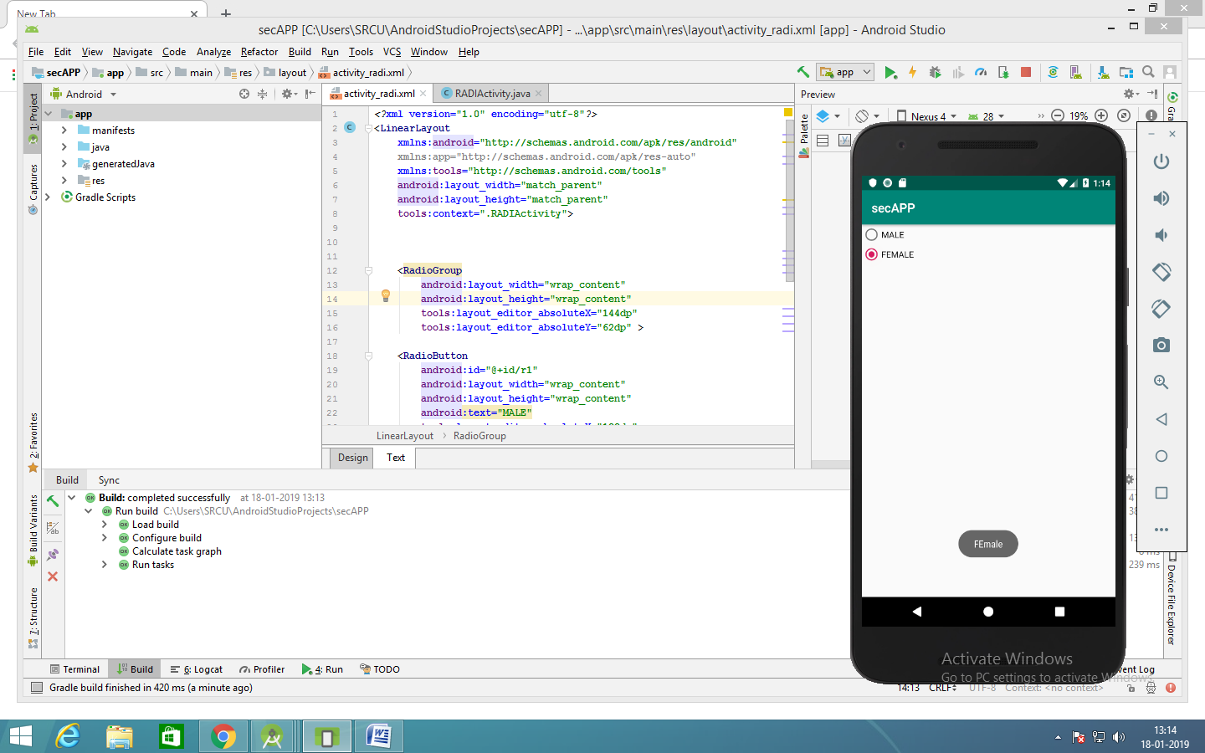

*<?***xml version="1.0" encoding="utf-8"***?>*<**LinearLayout  
 xmlns:android="http://schemas.android.com/apk/res/android"  
 xmlns:app="http://schemas.android.com/apk/res-auto"  
 xmlns:tools="http://schemas.android.com/tools"  
 android:layout_width="match_parent"  
 android:layout_height="match_parent"  
 tools:context=".RADIActivity"**>  
  
  
  
 <**RadioGroup  
 android:layout_width="wrap_content"  
 android:layout_height="wrap_content"  
 /**>  
  
 <**RadioButton  
 android:id="@+id/r1"  
 android:layout_width="wrap_content"  
 android:layout_height="wrap_content"**

**Android:onclick=”f1”  
 android:text="MALE"** />  
  
 <**RadioButton  
 android:id="@+id/r2"  
 android:layout_width="wrap_content"  
 android:layout_height="wrap_content"**

**Android:onclick=”f1”  
  
 android:text="FEMALE"** />  
</**RadioGroup**>  
  
</**LinearLayout**>

**import** android.support.v7.app.AppCompatActivity;  
**import** android.os.Bundle;  
**import** android.view.View;  
**import** android.widget.*;  
  
**public class** RADIActivity **extends** AppCompatActivity

{ RadioButton **jr1**,**jr2**;  
  
 **protected void** onCreate(Bundle savedInstanceState) {  
 **super**.onCreate(savedInstanceState);  
 setContentView(R.layout.***activity_radi***);  
  
 **jr1**=findViewById(R.id.***r1***);  
 **jr2**=findViewById(R.id.***r2***);  
  
  
 }  
  
  
 **public void** f1(View v)  
 {  
  
 **if**(v==**jr1**)  
 {  
 Toast.*makeText*( **this**,**jr1**.getText(),Toast.***LENGTH_SHORT***).show();  
  
 }  
  
 **if**(v==**jr2**)  
 {  
 Toast.*makeText*( **this**, **"FEmale"**, Toast.***LENGTH_LONG***).show();  
  
 }  
 }  
  
}